development process

We at Beyonders have keen interest in developing a drone that can be used in combats and for defence purposes . we have focused on basically on how drone can be more faster and self capable on itself and have less of human interaction for which we intend to apply these in our project

Self Routing Algorithm

Safety protocols

Dodging System

Stable flight patterns

REQUIREMENT ANALYSIS

Drone

developer

Sensors

chip-set and motherboard

controller

receiver and transmitters

GPS module

ARCHITECTURE
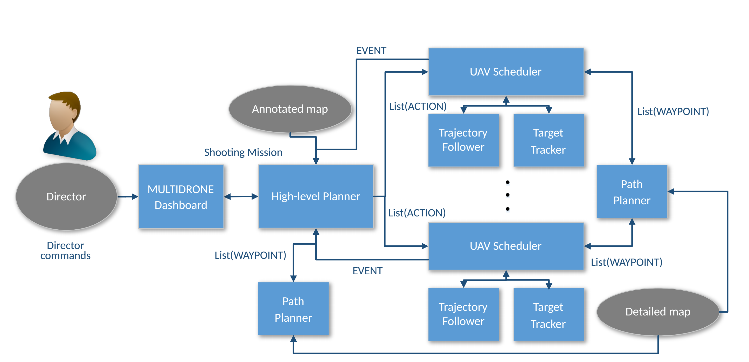

- we have focused on how the director has less interacted with the drone and how the drone has itself decided the path on duding the grounds and pressure , we target to achieve more updates with our architecture after implementing two or more features we have discussed above .

- DESIGN

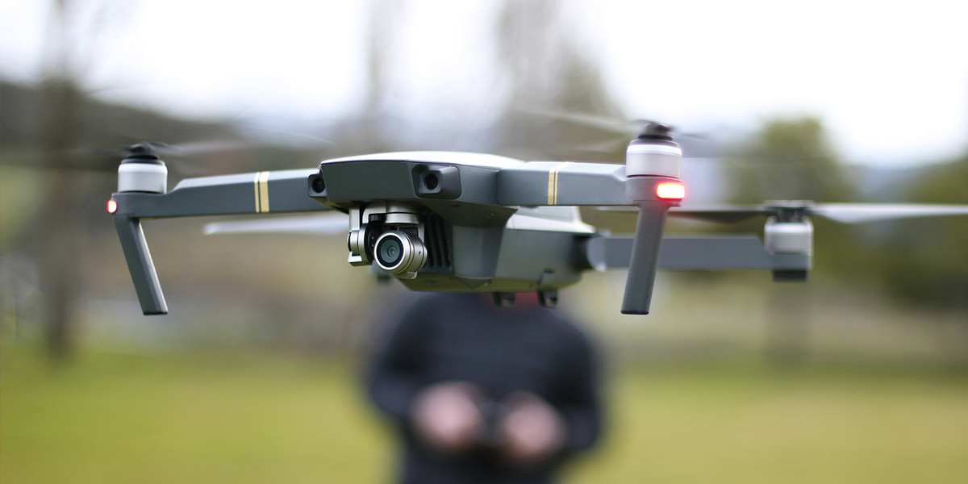
we have highly focused on making it more durable , faster , lighter and more independent controls for that we have kept aluminium as our core metal for making of the drone

basically the drone will have moreover the same design with all the important sensors under the head of the centre body of the drone and will have inside curving edges which will provide more wind endurance to the drone

